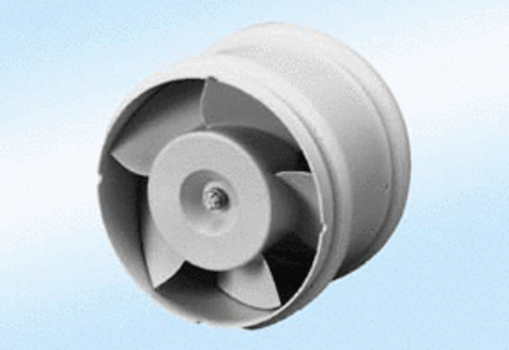ECA 11 E 24 VPacking unit: 1 pieceRange: A
Article number: 0080.0461Manufacturer: MAICO

