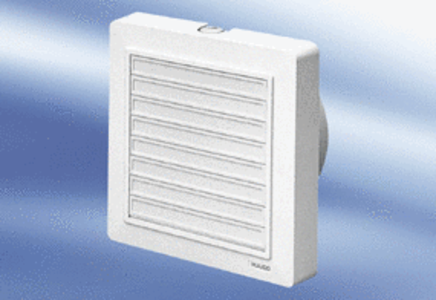Small room fan ECA 15/2 KPacking unit: 1 pieceRange:
Article number: 0080.0972Manufacturer: MAICO

