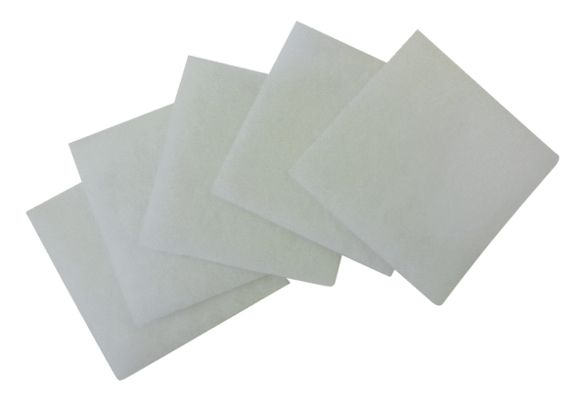Air filter, replacement ZF 17Packing unit: 5 piecesRange: B
Article number: 0093.0644Manufacturer: MAICO

