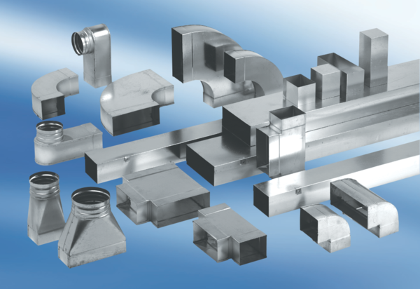90° angle elbow, symmetrical WB90SN/55/220/80Packing unit: 1 pieceRange: K
Article number: 0055.0608Manufacturer: MAICO

