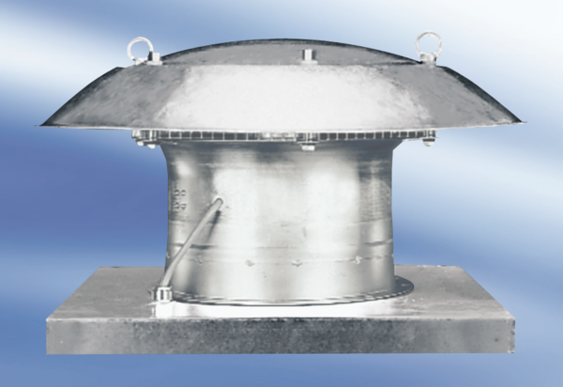Axial roof fan DZD 40/6 A-ExPacking unit: 1 pieceRange: C
Article number: 0087.0775Manufacturer: MAICO

