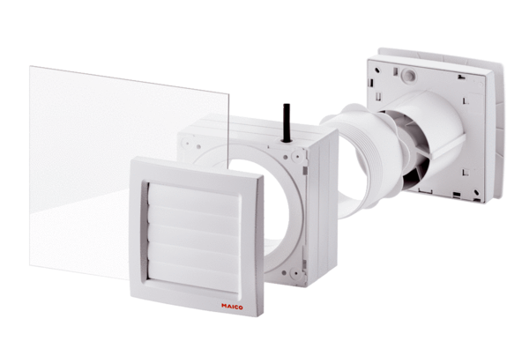Window installation kit FE 100/1 APPacking unit: 1 pieceRange: A
Article number: 0093.0499Manufacturer: MAICO

