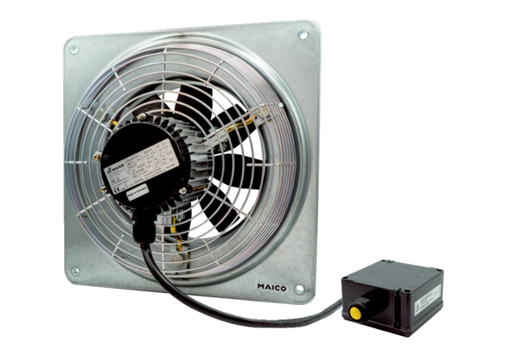Axial wall fan DZQ 45/6 B Ex ePacking unit: 1 pieceRange: C
Article number: 0083.0182Manufacturer: MAICO

