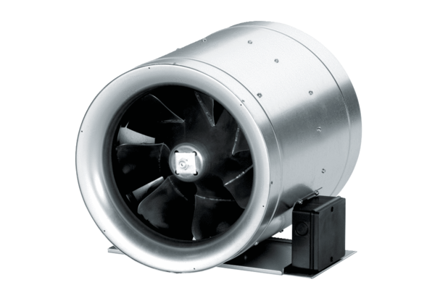Diagonal fan EDR 45Packing unit: 1 pieceRange: C
Article number: 0080.0661Manufacturer: MAICO

