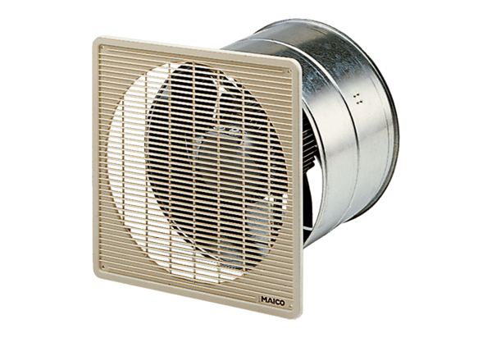EZF 40/4 BPacking unit: 1 pieceRange: C
Article number: 0085.0058Manufacturer: MAICO

