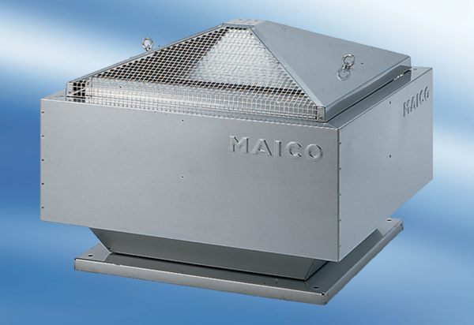Centrifugal roof fan DRD 50/6Packing unit: 1 pieceRange: C
Article number: 0087.0113Manufacturer: MAICO

