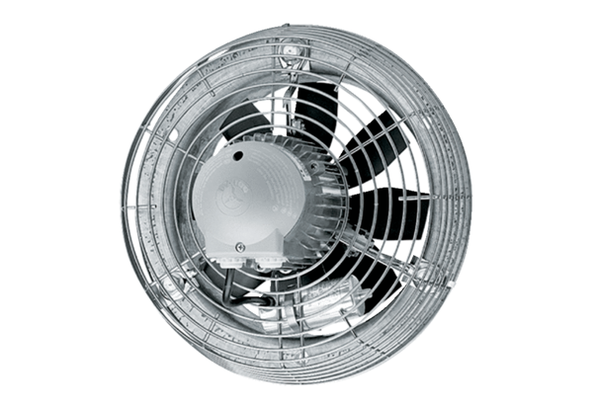Axial wall fan DZS 60/6 BPacking unit: 1 pieceRange: C
Article number: 0094.0064Manufacturer: MAICO

