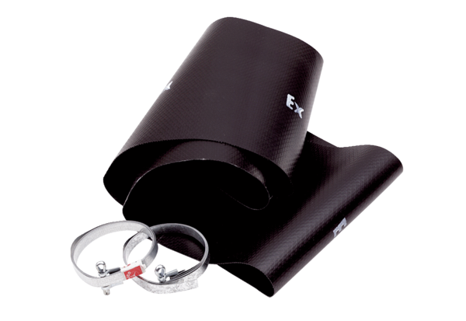Flexible cuff EL 40 ExPacking unit: 1 pieceRange: C
Article number: 0092.0235Manufacturer: MAICO

