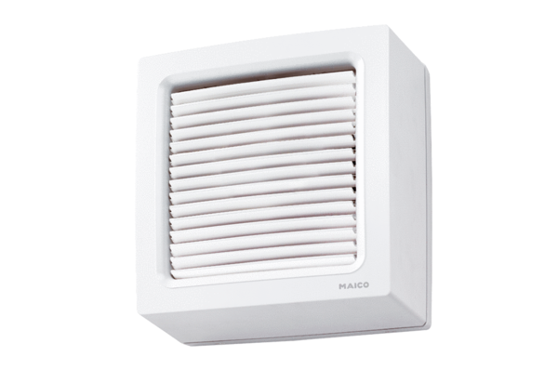Axial window fan EVN 22 RPacking unit: 1 pieceRange: C
Article number: 0080.0857Manufacturer: MAICO

