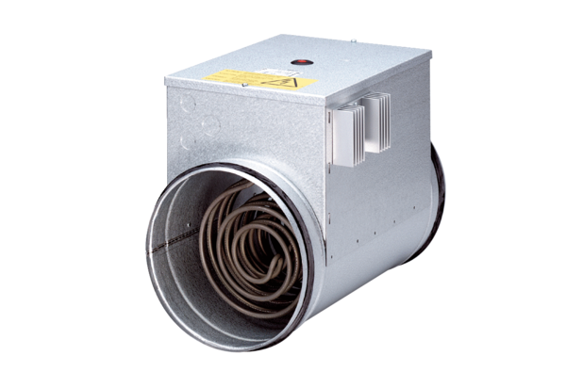Electrical air heater with controller ERH 16-2 RPacking unit: 1 pieceRange: C
Article number: 0082.0142Manufacturer: MAICO

