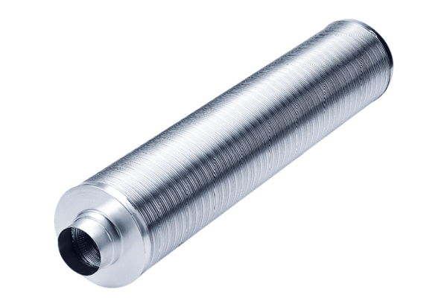Tubular sound absorber RSR 12/50Packing unit: 1 pieceRange: C
Article number: 0092.0322Manufacturer: MAICO

