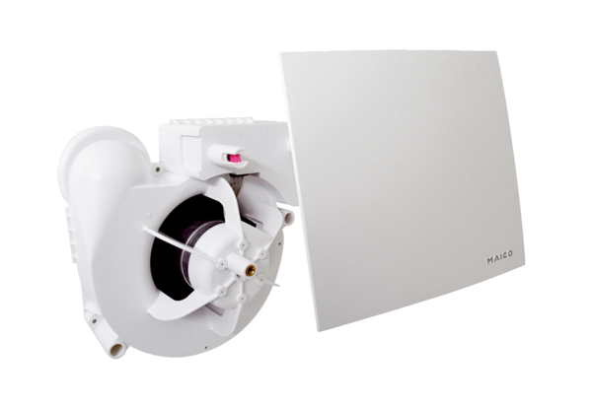Fan insert ER 100 EGPacking unit: 1 pieceRange:
Article number: 0084.0383Manufacturer: MAICO

