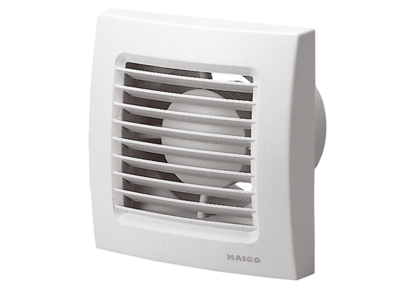Small room fan ECA 120 VZPacking unit: 1 pieceRange: A
Article number: 0084.0007Manufacturer: MAICO

