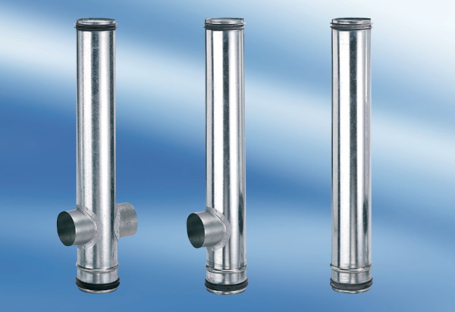BA 140-0Packing unit: 1 pieceRange: B
Article number: 0093.0056Manufacturer: MAICO

