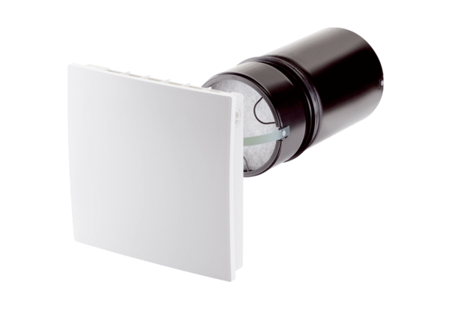Final assembly kit PP 45 RCPacking unit: 1 pieceRange: K
Article number: 0095.0242Manufacturer: MAICO

