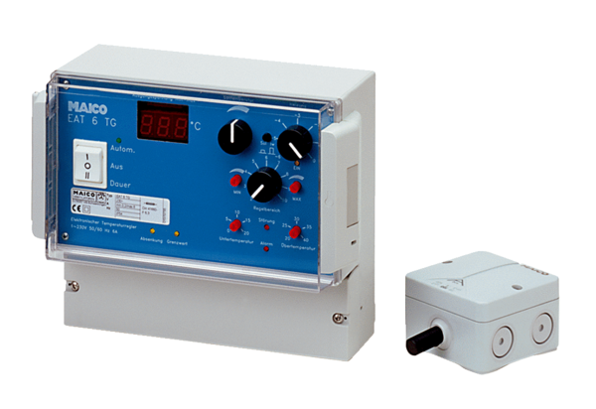Temperature control system EAT 6 TGPacking unit: 1 pieceRange: C
Article number: 0157.0755Manufacturer: MAICO

