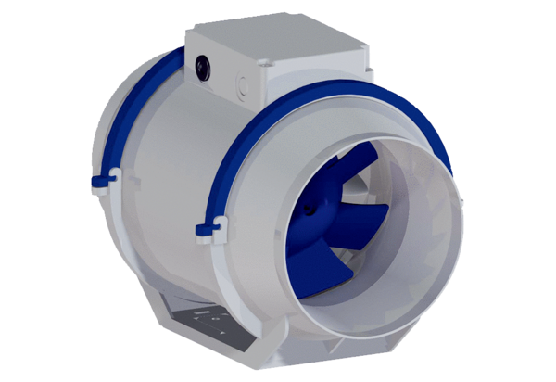Diagonal fan HDR 15Packing unit: 1 pieceRange: C
Article number: 0080.0538Manufacturer: MAICO

