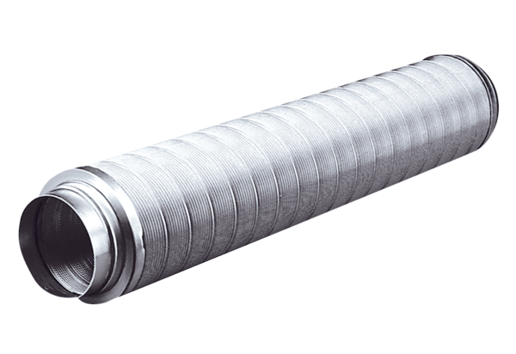Tubular sound absorber RSR 15Packing unit: 1 pieceRange: C
Article number: 0092.0313Manufacturer: MAICO

