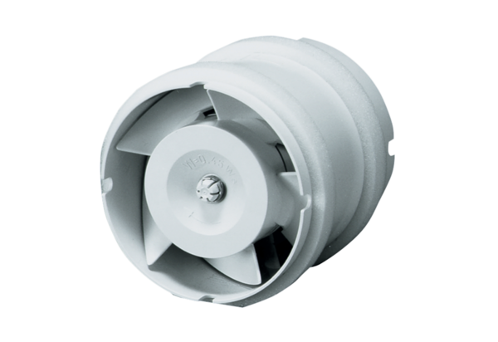Duct-mounted fan ECA 11 EPacking unit: 1 pieceRange: A
Article number: 0080.0460Manufacturer: MAICO

