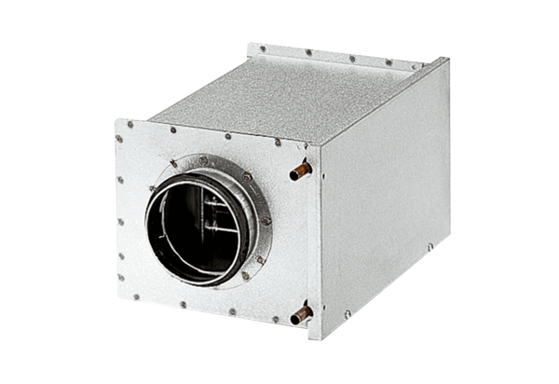Water air heater WRH 25-4Packing unit: 1 pieceRange: C
Article number: 0082.0120Manufacturer: MAICO

