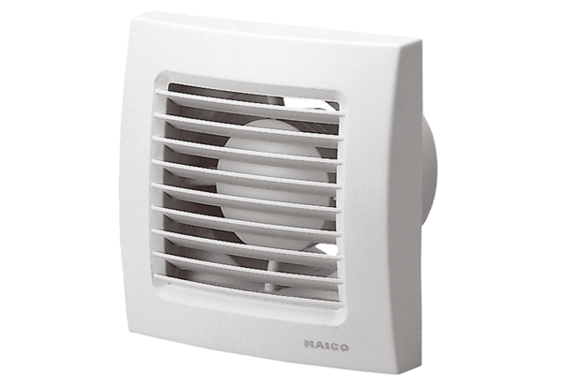Small room fan ECA 150/4Packing unit: 1 pieceRange: A
Article number: 0084.0036Manufacturer: MAICO

