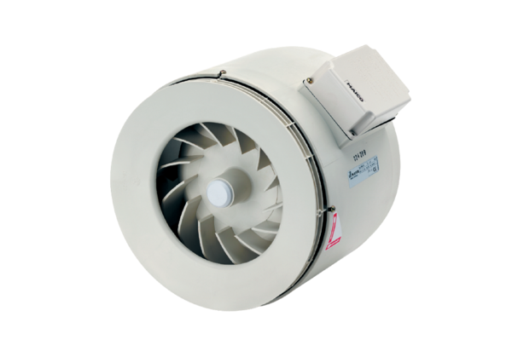Semi-centrifugal duct fan ERM 15Packing unit: 1 pieceRange: C
Article number: 0080.0203Manufacturer: MAICO

