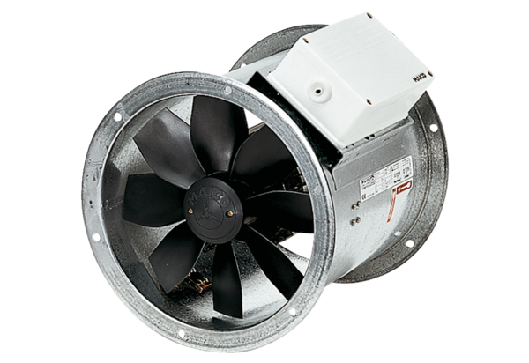Axial duct fan EZR 30/2 BPacking unit: 1 pieceRange: C
Article number: 0086.0005Manufacturer: MAICO

