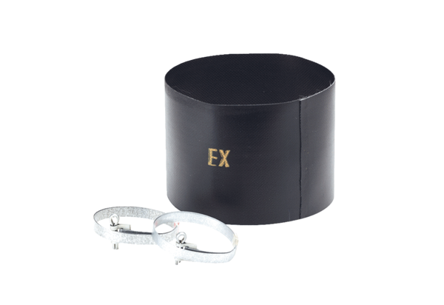Flexible cuff ELM 12 ExPacking unit: 1 pieceRange: C
Article number: 0092.0262Manufacturer: MAICO

