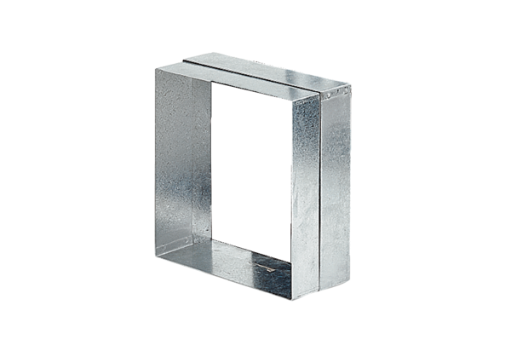Wall frame ER-MRPacking unit: 1 pieceRange: B
Article number: 0018.0024Manufacturer: MAICO

