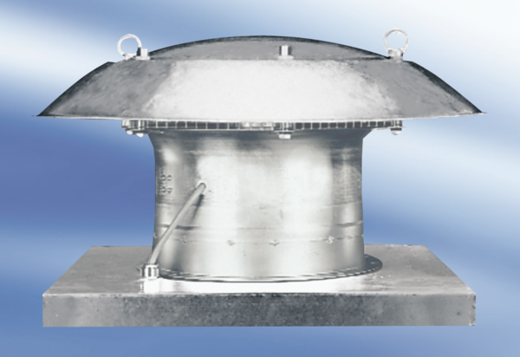Axial roof fan DZD 50/86 APacking unit: 1 pieceRange:
Article number: 0087.0448Manufacturer: MAICO

