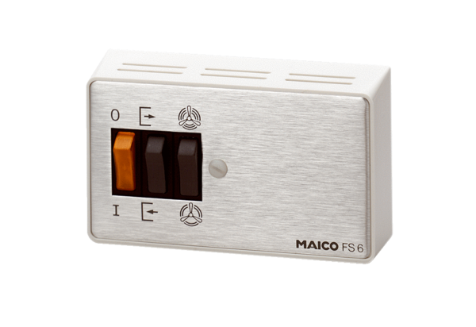Step switch, reversing switch FS 6Packing unit: 1 pieceRange: C
Article number: 0016.0106Manufacturer: MAICO

