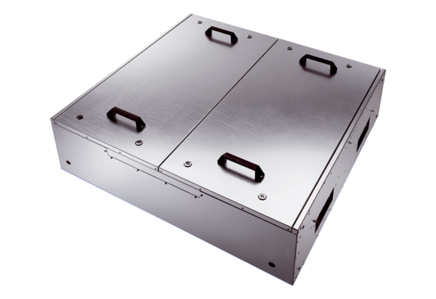Sound-insulated ventilation box KFR 6030Packing unit: 1 pieceRange: K
Article number: 0080.0961Manufacturer: MAICO

