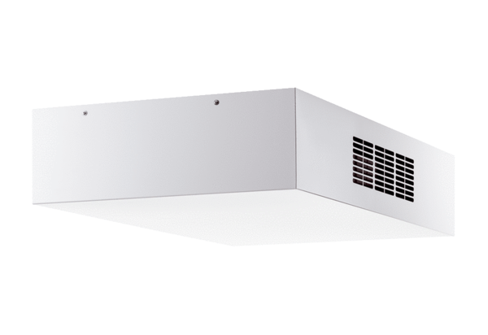Decentralised ventilation unit with heat recovery Trio QD-ARPacking unit: 1 pieceRange: K
Article number: 0095.0122Manufacturer: MAICO

