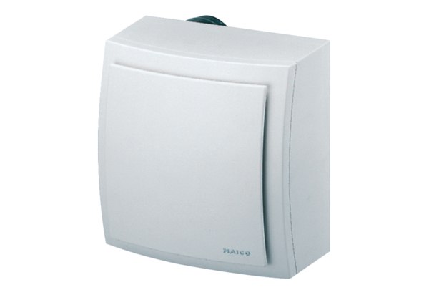Surface-mounted fan ER-AP 100 GPacking unit: 1 pieceRange: B
Article number: 0084.0173Manufacturer: MAICO

