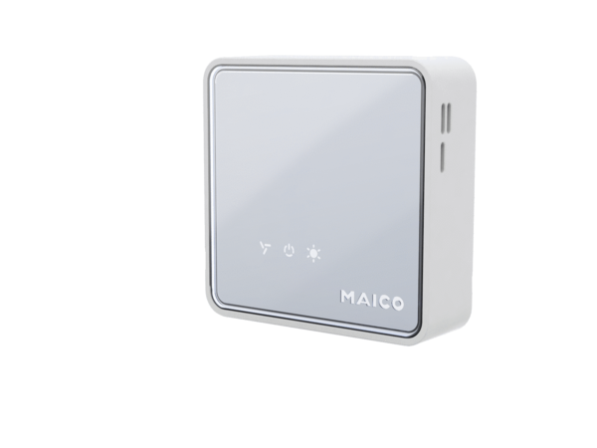Air quality controller EAQ 10/3Packing unit: 1 pieceRange: K
Article number: 0157.0829Manufacturer: MAICO

