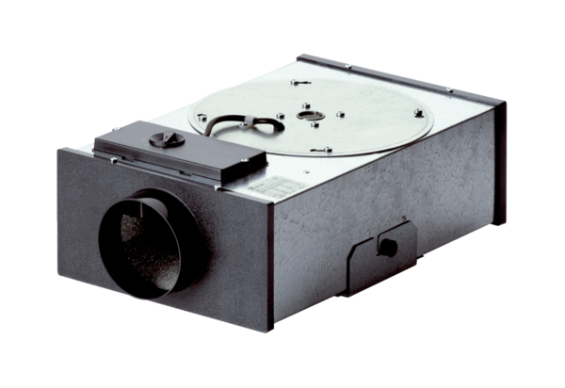Centrifugal flat box EFR 12 RPacking unit: 1 pieceRange: C
Article number: 0080.0573Manufacturer: MAICO

