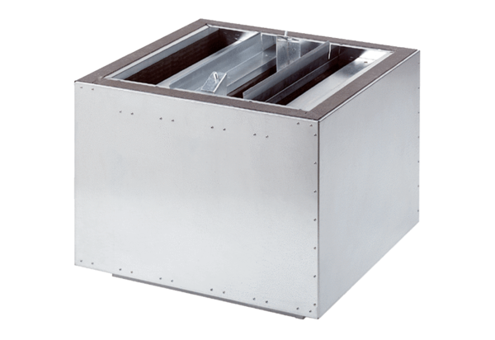Exhaust air silencer SDA 50Packing unit: 1 pieceRange:
Article number: 0092.0392ALTManufacturer: MAICO

