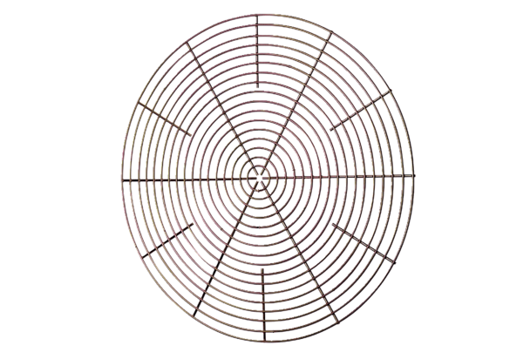Protective grille, metal SG 30Packing unit: 1 pieceRange: C
Article number: 0150.0116Manufacturer: MAICO

