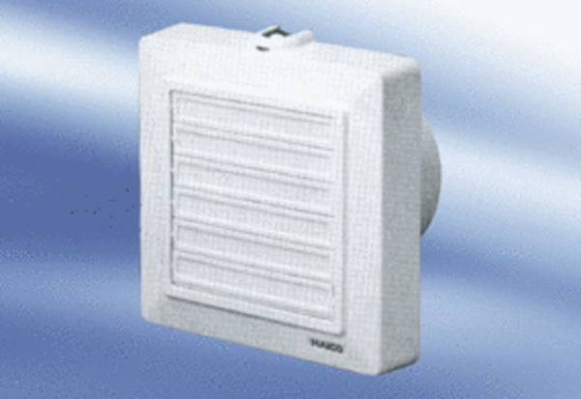Small room fan ECA 11-1 KPacking unit: 1 pieceRange:
Article number: 0080.0504Manufacturer: MAICO

