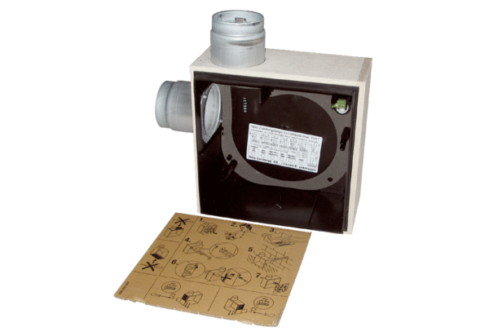Recessed-mounted housing ER - UPB/LPacking unit: 1 pieceRange: B
Article number: 0093.0970Manufacturer: MAICO

