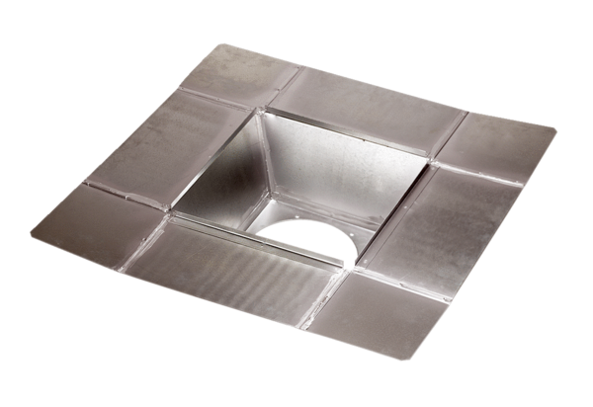Intermediate socket SZ 35Packing unit: 1 pieceRange: C
Article number: 0092.0290Manufacturer: MAICO

