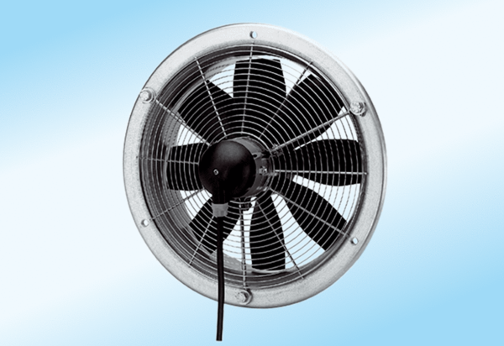Axial wall fan DZS 30/6 A-ExPacking unit: 1 pieceRange: C
Article number: 0094.0105Manufacturer: MAICO

