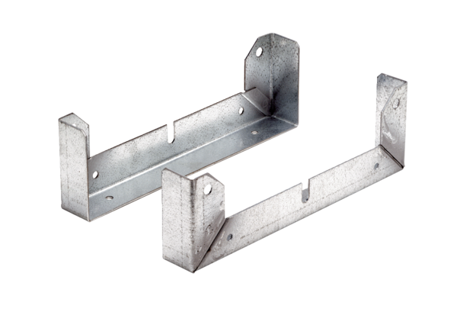Mounting foot FU 40Packing unit: 2 piecesRange: C
Article number: 0036.0073Manufacturer: MAICO

