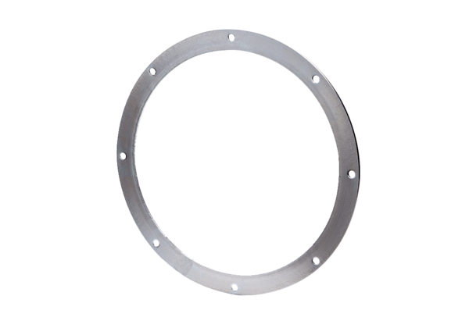Counter flange GF 25Packing unit: 1 pieceRange: C
Article number: 0056.0003Manufacturer: MAICO

