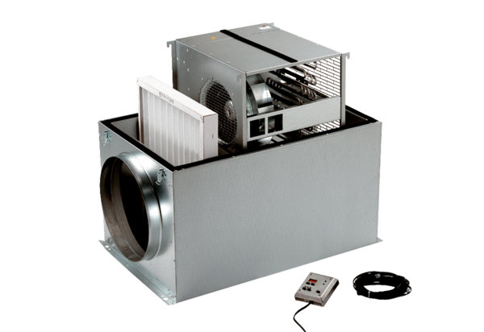Compact box ECR 25 ECPacking unit: 1 pieceRange: E
Article number: 0080.0082Manufacturer: MAICO

