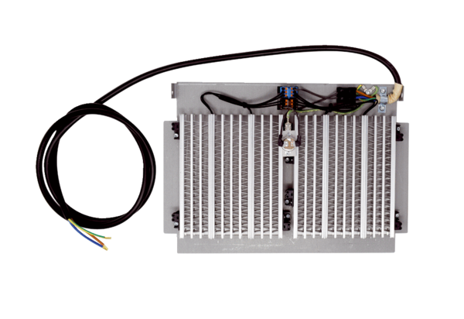PREHEATING REGISTER WS-VH 300Packing unit: 1 pieceRange: K
Article number: 0093.1322Manufacturer: MAICO

