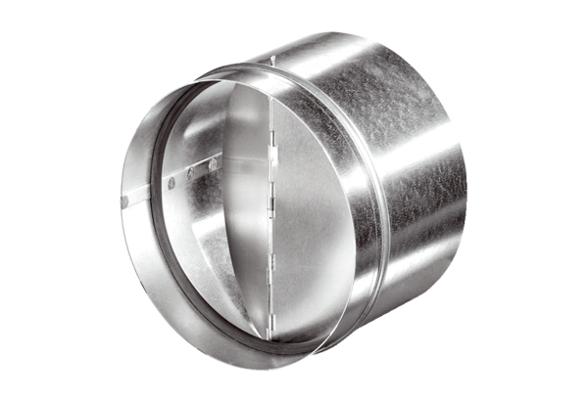Automatic backflow preventer AVM 12Packing unit: 1 pieceRange: C
Article number: 0093.0003Manufacturer: MAICO

