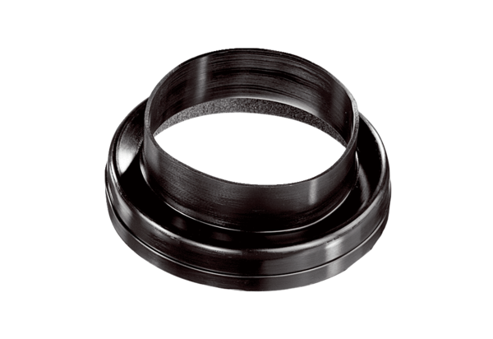Ventilation duct coupling MT-Ü125Packing unit: 1 pieceRange: K
Article number: 0059.0986Manufacturer: MAICO

