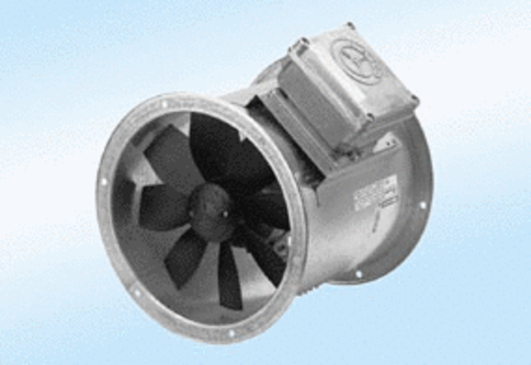Axial duct fan DZR 50/4 A-ExPacking unit: 1 pieceRange: C
Article number: 0086.0786Manufacturer: MAICO

