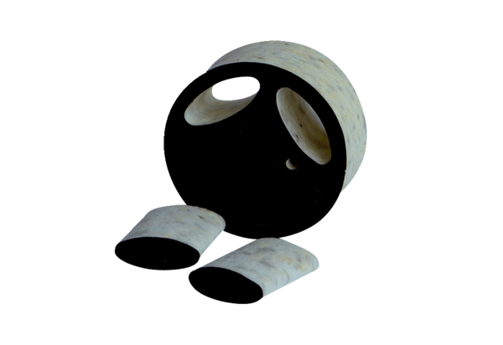Slide-in sound absorber SDE 12Packing unit: 1 pieceRange: C
Article number: 0044.0215Manufacturer: Jeven

